
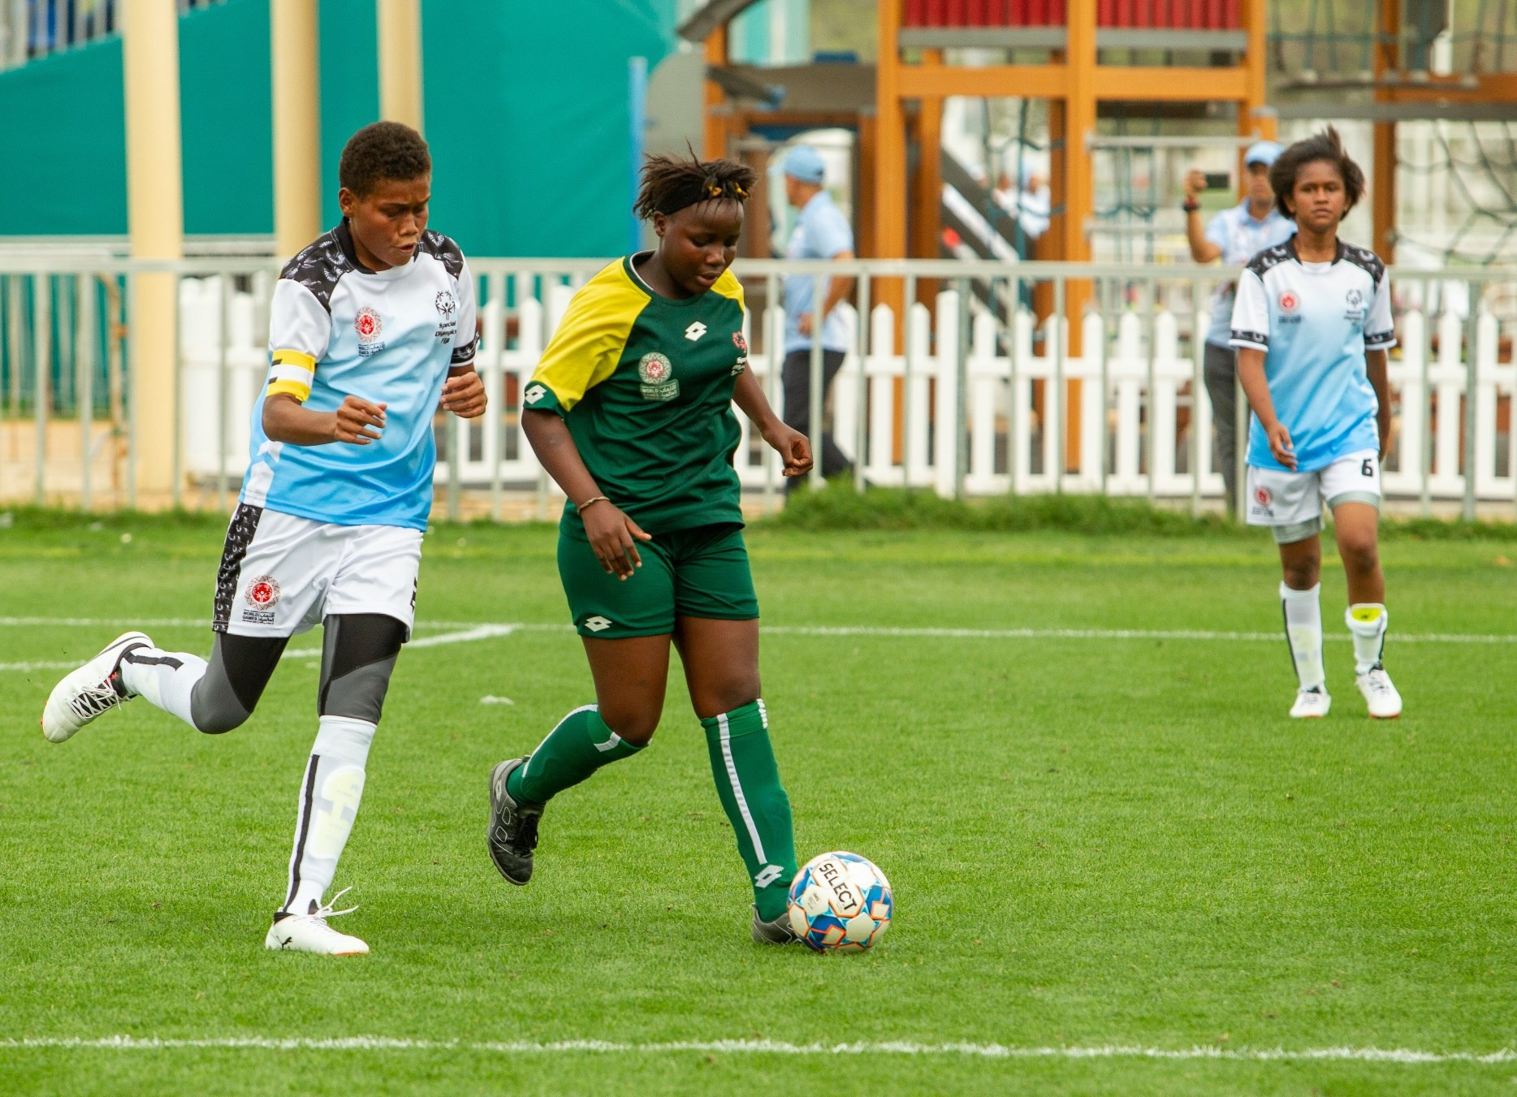


Football
Sport Rules

FOOTBALL SPORT RULES

TABLE OF CONTENTS
- GOVERNING RULES 4
- OFFICIAL EVENTS 4
  - Individual Skills Competition (ISC) 4
  - 5-a-side Team (outdoor) 4
  - 7-a-side Team and 8-a-side Team (outdoor) 4
  - 11-a-side Team Competition according to FIFA rules 4
  - Futsal Competition according to FIFA rules 4
  - Unified Sports® 5-a-side Team Competition 4
  - Unified Sports 7-a-side Team Competition 4
  - Unified Sports 8-a-side Team Competition 4
  - Unified Sports 11-a-side Team Competition 4
  - Unified Sports Futsal Team Competition 4
- DIVISIONING 4
  - Divisioning basis 4
  - Classification rounds. 4
  - Goalkeepers' assessments. 4
- GENERAL RULES AND MODIFICATIONS 5
  - 7-a-side and 8-a-side Football 10
    - Diagram 10
    - The Field of Play 10
    - The Ball 10

FOOTBALL SPORT RULES

    - The Number of Players 10
    - Players’ Equipment 11
    - The Referee 11
    - The Assistant Referees 11
    - Duration of the Game 11
    - Start of Play 11
    - Ball In and Out of Play 11
    - Goal Clearance 11
    - Infringement penalties 12
    - Method of Scoring 12
    - Fouls and Misconduct (except there is no offside) 12
    - Restart Exception 15
    - Free Kick 15
    - Penalty Kick 15
    - Kick In (Equivalent to the throw in for 11-a-side) 15
    - Infringement penalties 15
    - Corner-Kick 16
    - Water Break 16
    - Overtime/Penalty Kick 16
    - Coaching from Bench Area 17

FOOTBALL SPORT RULES

GOVERNING RULES
The Official Special Olympics Sports Rules for Football (Soccer) shall govern all Special Olympics competitions. As an international sports program, Special Olympics has created these rules based upon Federation International de Football Association (FIFA) rules for football (soccer) found at https://inside.fifa.com/about-fifa/organisation/contact-fifa/laws-of-the-game. FIFA or National Governing Body (NGB) rules shall be employed except when they are in conflict with the Official Special Olympics Sports Rules for Football (Soccer) or Article I. In such cases, the Official Special Olympics Sports Rules for Football (Soccer) shall apply.

An athlete with Down syndrome who has been diagnosed with Atlanto-axial Instability may not participate in football (soccer) events.

Refer to Sport Rules Article 1 for more information about Codes of Conduct, Training Standards, Medical and Safety Requirements, Divisioning, Awards, Criteria for Advancement to Higher Levels of Competition, and Unified Sports.

OFFICIAL EVENTS
The range of events is intended to offer competition opportunities for athletes of all abilities. Programs may determine the events offered and, if required, provide guidelines for managing those events.
Coaches are responsible for providing training and event selection appropriate to each athlete’s skill and
interest.
The following is a list of official events available in Special Olympics:
  - Individual Skills Competition (ISC)
  - 5-a-side Team (outdoor)
  - 7-a-side Team and 8-a-side Team (outdoor)
  - 11-a-side Team Competition according to FIFA rules
  - Futsal Competition according to FIFA rules
  - Unified Sports® 5-a-side Team Competition
  - Unified Sports 7-a-side Team Competition
  - Unified Sports 8-a-side Team Competition
  - Unified Sports 11-a-side Team Competition
  - Unified Sports Futsal Team Competition

DIVISIONING
  - Teams may be divided based on the Team Skill Assessment found in Section D of these rules, a Prior Divisioning Form based on the SOEE Divisioning DVD, or a prior Divisioning/Team Rating form approved by the Program, and by an on-site classification round.
  - In the classification rounds, teams will play a minimum of two evaluation games of at least eight minutes (5-a-side), eight minutes (7-a-side), or fifteen minutes (11-a-side).
  - The Divisioning Committee shall ensure that all goalkeepers are adequately assessed.

FOOTBALL SPORT RULES

UNIFIED SPORTS®
  - Unified Events Required Ratios
    - 5-a-Side Football: 3 athletes to 2 Unified partners
    - 7-a-Side Football: 4 athletes to 3 Unified partners
    - 8-a-Side Football: 4 athletes to 4 Unified partners
    - 11-a-Side Football: 6 athletes to 5 Unified partners
    - Futsal: 3 athletes to 2 Unified partners
  - It is required that athletes and Unified partners are of similar age and have similar ability in all events. For more information on similar age and ability, please see Sport Rules Article 1 Section 14.1.2.

GENERAL RULES AND MODIFICATIONS

  - 7-a-side and 8-a-side Football
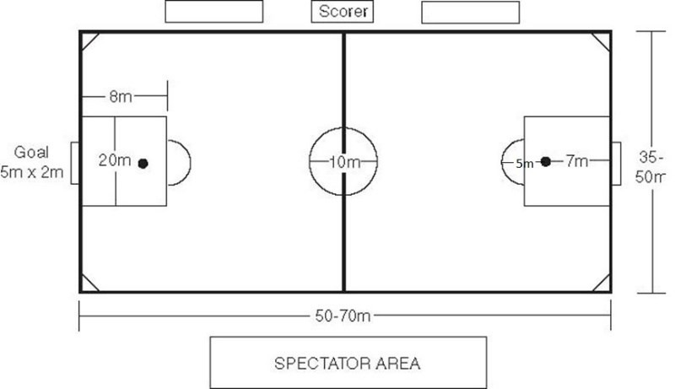
    - Diagram

5.2.2 | The Field of | Play
 | 5.2.2.1 | The 7-a-side and 8-a-side field shall be a rectangle: maximum dimensions of 70
 |  | Meters by 50 meters, minimum dimensions of 50 meters by 35 meters. The
 |  | A smaller field is recommended for lower ability teams.
 | 5.2.2.2 | The goal size shall be five meters by two meters.
 | 5.2.2.3 | The goal area shall be eight meters by 20 meters.
 | 5.2.2.4 | The recommended playing surface is grass.
5.2.3 | The Ball
 | 5.2.3.1 | Ages 8-12: Size 4 balls, not more than 66 centimeters (26 in) and not less than
 |  | 63.5 centimeters (25 in).
 | 5.2.3.2 | All other players: Size 5 ball, not more than 70 centimeters (28 in) and not less
 |  | More than 68 centimeters (27 in).
    - The Number of Players
      - Allowable roster size is to be determined by the Competition Committee. At the Special Olympics World Games, the roster size may not exceed 12 players.
      - The game is played between two teams, each consisting of seven or eight players, one of whom shall be the goalkeeper. A minimum of five players shall be on the field at any one time.
      - Substitutions are unlimited in number (players may return to the field after being substituted). Substitutions can be made any time the ball is out of bounds, between periods, after a goal is scored or during a timeout for an injury. The coach must signal the referee or linesman in order to make a

FOOTBALL
SPORT RULES
substitution. A substituted player can only come on to the field when given a signal by the referee.
5.2.5 Players’ Equipment

      - Shirts must be numbered.
      - Shin pads are required.
      - No metal studs are allowed.
    - The Referee
      - Each match is controlled by one referee who has full authority to enforce the Laws of the Game in connection with the match to which he has been appointed.
    - The Assistant Referees
      - Two assistant referees are appointed to each match for Regional and International Competitions.
      - For Local, Program, and National Competitions, it is recommended to have two referees if there are not enough Assistant Referees.
    - Duration of the Game:
      - The duration of the game shall be two equal periods of twenty minutes with a halftime interval of five minutes. The referee should be responsible for keeping the playing time.
      - If overtime is used to break a tie, two five-minute overtime periods are used. If the game is still tied, penalty kicks will be used to break the tie. (See 11-a-side tie-break protocol: 4.3.16).
    - Start of Play
      - All players, except the player taking the kick-off, must be in their own half of the field of play.
      - The ball must be stationary on the center mark.
      - The referee gives a signal.
      - The ball is in play when it is kicked and clearly moves.
      - A goal can be scored directly against the opponent from the kick-off; if the ball
If it directly enters the kicker’s goal, a corner kick is awarded to the opposing team.
    - Ball In and Out of Play:
      - Ball over the sideline results in a kick in.
      - Ball over the end line results in a goal clearance or a corner kick.
      - The ball must be completely over the line to be considered out of play.
    - Goal Clearance
      - A goal kick is awarded when the whole of the ball passes over the goal line, on the ground or in the air, having touched a player on the attacking team, and a goal is not scored.
      - A goal may be scored directly from a goal kick, but only against the opposing team; if the ball enters directly into the kicker’s goal, a corner kick is awarded to the opponents. The ball must be stationary and is kicked from any point within the goal area by a player on the defending team. The ball is in play when.

FOOTBALL SPORT RULES

it is kicked and clearly moves. Opponents must be outside the penalty area until the ball is in play.
        - If, after the ball is in play, the kicker touches the ball again before it has touched another player, an indirect free kick is awarded if the kicker commits a handball offence:
          - A direct free kick is awarded.
        - A penalty kick is awarded if the offense occurred inside the kicker’s penalty area, unless the kicker was the goalkeeper, in which case an indirect free kick is awarded.
        - If, when a goal kick is taken, any opponents are inside the penalty area because they did not have time to leave, the referee allows play to continue. If an opponent who is in the penalty area when the goal kick is taken or enters the penalty area before the ball is in play, touches or challenges for the ball before it is in play, the goal kick is retaken.
        - If a player enters the penalty area before the ball is in play and fouls or is fouled by an opponent, the goal kick is retaken and the offender may be cautioned or sent off, depending on the offense.
        - For any other offence, the kick is retaken.
      - The above rules of goal clearance also apply when a goalkeeper gains possession, with his hands, of a ball that is still in play.
    - Infringement penalties
      - If the ball thrown by the goalkeeper passes beyond the goalkeeper’s half of the field without first having been touched by a player or without having touched the ground, the referee shall award an indirect free kick for the opposing team from any point on the halfway line.
      - From the goalkeeper’s throw, if the ball is touched by any player inside the
penalty area, the throw shall be retaken.
    - Method of Scoring
      - The whole ball must have completely crossed the line inside the goal to count as a goal.
    - Fouls and Misconduct (except there is no offside)
      - A Direct free kick is awarded if a player commits any of the following offences against an opponent in a manner considered by the referee to be careless, reckless, or using excessive force:
        - Charges,
        - Jumps at
        - Kicks or attempts to kick.
        - Pushes.
        - Strikes or attempts to strike (including head-butt);

FOOTBALL SPORT RULES

        - Tackles or challenges.
        - Trips or attempts to trip.
      - If an offence involves contact, it is penalized by a direct free kick.
        - Careless is when a player shows a lack of attention or consideration when making a challenge or acts without precaution. No disciplinary sanction is needed.
        - Recklessness is when a player acts with disregard for the danger to, or consequences for, an opponent and must be cautioned.
        - Using excessive force is when a player exceeds the necessary use of force and/or endangers the safety of an opponent and must be sent off.
      - A direct free kick is awarded if a player commits any of the following offences:
        - A handball offence (except for the goalkeeper within their penalty area)
        - Holds an opponent.
        - Impedes an opponent with contact.
        - Bites or spits at someone on the team lists or a match official.
        - Throws an object at the ball, an opponent, or a match official, or makes contact with the ball with a held object.
      - An indirect free kick is awarded if a player:
        - Plays in a dangerous manner.
        - Impedes the progress of an opponent without any contact being made.
        - Is guilty of dissent, using offensive, insulting, or abusive language and/or action(s) or other verbal offences.
        - Prevents the goalkeeper from releasing the ball from the hands or kicking or attempting to kick the ball when the goalkeeper is in the process of releasing it
        - Initiates a deliberate trick for the ball to be passed (including from a free kick or goal kick) to the goalkeeper with the head, chest, knee, etc., to circumvent the Law, whether or not the goalkeeper touches the ball with the hands; the goalkeeper is penalized if responsible for initiating the deliberate trick
        - Commits any other offence, not mentioned in the Rules, for which play is stopped to caution or send off a player.
      - An indirect free kick is awarded if a goalkeeper, inside their penalty area, commits any of the following offences:
        - Controls the ball with the hand/arm for more than six seconds before releasing it

FOOTBALL SPORT RULES

        - Touches the ball with the hand/arm after releasing it and before it has touched another player.
        - Touches the ball with the hand/arm; unless the goalkeeper has clearly kicked or attempted to kick the ball to release it into play, after:
          - It has been deliberately kicked to the
goalkeeper by a teammate
          - Receiving it directly from a thrown-in (kick-in) taken by a teammate
        - A goalkeeper is considered to be in control of the ball with the hand(s) when:
          - The ball is between the hands or between the hand and any surface (e.g., ground, own body) or by touching it with any part of the hands or arms, except if the ball rebounds from the goalkeeper or the goalkeeper has made a save.
          - Holding the ball in the outstretched open hand 5.2.14.5.4.3. Bouncing it on the ground or throwing it in the air
air
        - A goalkeeper cannot be challenged by an opponent when in control of the ball with the hand(s)
        - Playing in a dangerous manner
          - Playing dangerously is any action that, while trying to play the ball, threatens injury to someone (including the player themselves) and includes preventing a nearby opponent from playing the ball for fear of injury.
        - Impeding the progress of an opponent without contact 5.2.14.5.7.1. Impeding the progress of an opponent means
moving into the opponent’s path to obstruct,
block, slow down, or force a change of direction when the ball is not within playing distance of either player.
          - All players have a right to their position on the field of play; being in the way of an opponent is not the same as moving in the way of an opponent.
          - A player may shield the ball by taking a position between an opponent and the ball if the ball is within playing distance and the opponent is not

FOOTBALL SPORT RULES

Held off with the arms or body. If the ball is within playing distance, the player may be fairly charged by an opponent.
      - All fouls result in an indirect free kick (except penalty kick, direct free kick).
      - If a player is expelled from the game (receives two yellow cards or a red card), this player may not re-enter the game. His team must play a player down for two minutes.

    - Restart Exception
        - Keeping a check of the two minutes shall be the task of the 1st referee (Head Referee).
        - The player who enters the game as a substitute after two minutes may only do so with the consent of the referee when the ball is out of bounds.

      - Any free kick that is awarded to the defending team inside their own penalty area will be restarted with a throw from the goalkeeper.
    - Free Kick
      - Opposing players must retire at least five meters from the ball for all free kicks.
      - When an indirect free kick is awarded to the attacking team inside the penalty area, within five meters from the goal line, the referee must place the ball five meters from the goal line.
    - Penalty Kick
      - A penalty kick is taken from the seven-meter mark. All players except the kicker and the goalkeeper must retire outside the penalty area and arc. The goalkeeper must stand on his/her goal line until the penalty kick is taken.
    - Kick In (Equivalent to the throw-in for 11-a-side)
      - When the whole of the ball passes over a sideline, it shall be kicked back into the game, from the place where it crossed the line (on the sideline), by a player from the opposing team to that of the player who last touched it. The ball must be stationary before being kicked. It shall be deemed in play when the ball is kicked and clearly moves. The ball cannot be played again by the kicker until another player has touched it. The players from the opposing team must retire at least 5 meters from the spot where the kick is being taken.
      - A goal cannot be scored directly from a kick-in.
      - A goalkeeper may not touch the ball with hands receiving it directly from a kick-in by a teammate.
      - A goalkeeper may not touch the ball with hands after it has been deliberately kicked to him/her by a teammate.
    - Infringement penalties
      - If the player taking the kick-in plays the ball for a second time before another player has touched it, an indirect free kick is awarded to the opposing team from the point where the infringement occurred.

FOOTBALL SPORT RULES

    - Corner-Kick
      - Awarded to the attacking team when a player from the defending team kicks the ball over his/her own end line.
      - Opposing players must retire at least 5 meters from the ball.
    - Water Break
      - In the case of extreme heat, the official representative from the Competition Committee (e.g., Field Manager) may signal to the referee to introduce a water break (maximum of three minutes) at a natural break in play, approximately halfway through each half.
    - Overtime/Penalty Kick
      - In regular league play, ties are considered final.
      - In tournament play, two five-minute overtime periods are used.
      - If the game is still tied after the overtime periods, penalty kicks shall be used to decide the game.
        - The referee chooses the goal at which the kicks will be taken.
        - The referee tosses a coin, and the team whose captain wins the toss decides whether to take the first or the second kick.
        - Each team is responsible for selecting five players from those on the field of play at the end of the match and for the order in which they will take the kicks.
        - The highest score after five penalty kicks is declared the winner. The referee keeps a record of the kicks being taken.
        - Subject to the conditions explained below, both teams take five kicks.
        - The kicks are taken alternately by the teams.
        - If, before teams have taken five kicks, one has scored more goals than the other could score, even if it were to complete five kicks, no more kicks are taken.
        - If, after both teams have taken five kicks, both have scored the same number of goals, or have not scored any goals, kicks continue to be taken in the same order until one team has scored a goal more than the other from the same number of kicks.
        - A goalkeeper who is injured while kicks are being taken from the penalty mark and is unable to continue as a goalkeeper may be replaced by a named substitute.
        - Except the foregoing case, only players who are on the field of play at the end of the match, which includes extra time where appropriate, are eligible to take penalty kicks.
        - If at the end of the match one team has a greater number of players than its opponents, it must reduce its numbers to equate with that of its opponents. The team captain must inform the referee of the name and number of the excluded player. The

FOOTBALL SPORT RULES

The referee must ensure that an equal number of players from each team remains within the center circle, and they shall take the kicks.
        - A different player takes each kick, and all eligible players must take a kick before any player can take a second kick.
        - Once all eligible players have taken a penalty kick, the same sequence does not have to be followed as in the first round of kicks.
        - An eligible player may change places with the goalkeeper at any time when kicks from the penalty mark are being taken.
        - In Unified Sports penalty kicks, alternate kicks by athletes and partners must be taken, with the athlete taking the first penalty kick for each team.
    - Coaching from the Bench Area
      - A team bench area will be provided for each team.
      - Each bench area will be defined by a marked-off rectangle, 15 meters in length, located on the sideline at least 5 meters away from the sideline and within 10 meters of the halfway line.
      - A team bench should be provided within each area.
      - Coaches and substitutes must remain within the bench area at all times. Only one coach can stand. Failure to adhere to this may result in the coach being sent off the field of play. Coaches are expected to restrict their coaching to simple verbal encouragement.
      - Verbal abuse of players or officials, or excessive and explicit coaching from the sidelines, will be considered unsportsmanlike conduct and may result in a warning from the Referee. If such behavior persists, the referee may eject the offending coach from the field.

  - Unified Sports Team Competition (11-a-side, 8-a-side, 7-a-side and 5-a-side, Futsal)
    - The Number of Players
      - The roster shall contain a proportionate number of athletes and partners.
      - During play, a team should not exceed:

FOOTBALL SPORT RULES

        - 7-a-side Lineup: A team is allowed to play with a maximum of seven and a minimum of five players during competition. Only the following lineups are permitted:
4 athletes and 3 partners
3 athletes and 3 partners
3 athletes and 2 partners
          - Failure to adhere to the required ratio results in a forfeit.

      - Each team shall have an adult non-playing coach responsible for the lineup and conduct of the team.
  - Individual Skills Competition (ISC)
    - The ISC consists of three events: dribbling, shooting, and run and kick. Competitors should first go through a divisioning round where each athlete performs at each event once. The total score from the three events is then used to place players in divisions with others of similar abilities for the competition (medal) round. In the medal round, each player should perform each event twice. The total score from the two rounds is added together to give the final score.
      - Individual Skills Competition — Event Number 1: Dribbling
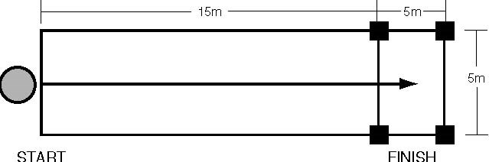
LINE ZONE

FOOTBALL SPORT RULES

