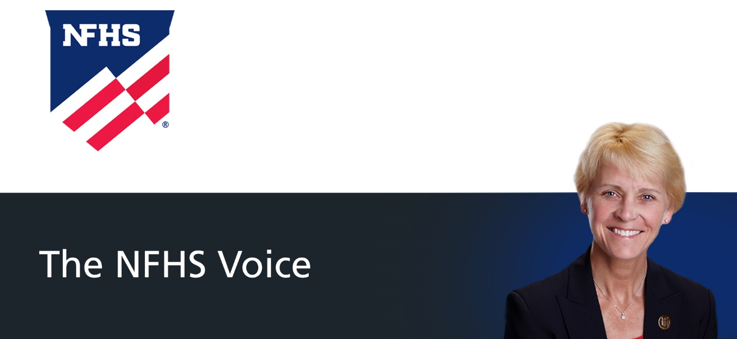

Schools Encouraged to Take Precautions Against COVID-19, Heat as New School Year Begins

Dr. Karissa L. Niehoff, NFHS Executive Director
@KarissaNFHS
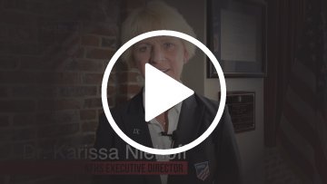
Periodically, The NFHS Voice will be presented in the form of video. As the new school begins, NFHS Executive Director Karissa Niehoff looks forward to everyone being back together, while encouraging schools to take precautions against heat and COVID-19, which would include the opportunity for students to be vaccinated.
View this week's video version of The NFHS Voice by clicking the linked image above.

Dr. Karissa L. Niehoff is in her third year as executive director of the National Federation of State High School Associations (NFHS) in Indianapolis, Indiana. She is the first female to head the national leadership organization for high school athletics and performing arts activities and the sixth full-time executive director of the NFHS. She previously was executive director of the Connecticut Association of Schools-Connecticut Interscholastic Athletic Conference for seven years.

